PolyPlots
(July 14, 2024)
PolyPlots is an abstract math strategy game and brainteaser for 1-4 players, aged 5+. Using 13-sided polygon tiles called polykites, players align and connect tiles to claim territory with coins matching simple math outcomes. The theme is growing fruits on triangular plots of land. Coins represent fruit crops.

WOODEN LASERCUT COMPONENTS
- 30 polykite tiles
- 80 coins (4 colored sets of 20)
- 2 dice.

GOAL:  Score the highest points by claiming plots. | 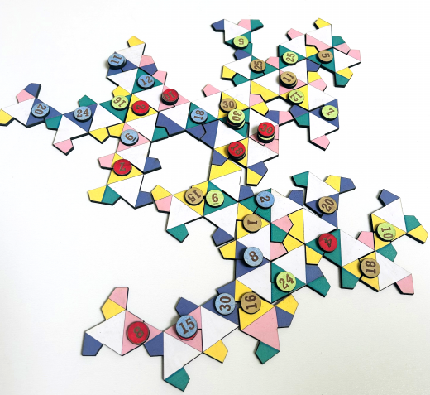
SETUP:
- Shuffle the tiles and place face down between the players.
- Give each player 20 coins of the same colour.
- Each player takes one tile placing it face up.
- Place a random starter tile between the players.

GAME PLAY:
Playing in turns, a player drops one of their tiles in an attempt to form a triangular shape of any color. If a triangle is formed, the player rolls the dice and forms an equation from the two numbers. The equation dictates which coin to place on the plot.
Alternatively, the coin can be placed on a territory claimed by another player, but only if the equation is higher than the value of the coin already in place.
If a coin cannot be placed, their turn ends.
Play until all tiles have been laid.

Claiming a Plot (Triangle):
To claim a plot, place the coin matching the equation on any completed triangle. The triangle does not need to match your color, however, all sections of the triangle must be of the same color.
Stacking Coins to Steal a Plot:
You may stack a coin on another coin of any color as long as the new coin’s value is higher than the top coin.

Bonus:
It is possible to form two triangles at the same time. In this case, you may place one coin on each triangle, using two separate equation solutions.

Equation (Number Sentence) Outcomes:
Upon rolling the dice, a player chooses the outcome of a mathematical equation (number sentence) from the two numbers. Only 20 outcomes are possible between 1-36. The outcome or solution is from addition, subtraction, multiplication or division of the two numbers. For example, rolling 3 and 5 can yield 2, 8 or 15 from subtraction, addition or multiplication of the two numbers.

STRATEGY:
Try to claim an important triangle using the highest mathematical outcome. Knowing that a player automatically gets 10 points for each triangle matching their color, you can forfeit a plot by placing a coin on a differently colored triangle.

SCORING & WINNING:
Each player automatically gets 10 points for each triangle matching their color. Add up the visible coins of the same color. Total the two numbers to get a final score.
The player with the highest score wins to round. In case of a tie, the player with the most plots wins. If still a tie, the player with the highest coins wins. Play at least two rounds.
Scoring Example:
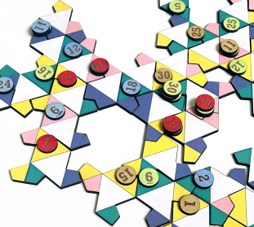 | Green (164): 7 plots = 70  5+25+12+30+16+6=94  Yellow (142): 6 plots = 60  30+25+11+15+1=82  Blue (103): 3 plots = 30  12+24+11+6+18+2=73  Red (97): 3 plots = 30  2+10+30+18+7=67
SOLO GAME PLAY:
This mode requires you to solve a brainteaser by creating as many perfect triangles of the same color as possible using all 50 tiles.

Mathematical Equations from Dice Rolls 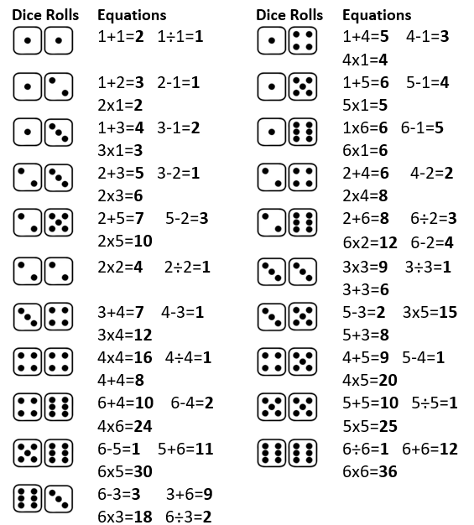
POLYKITE BACKGROUND:
Polykites were the miracle mathematical shape discovered in 2023. These 13-sided polygons allow a pattern to be formed that never repeats.
On March 20, 2023, a group of computer scientists (David Smith, Joseph Samuel Myers, Craig Kaplan and Chaim Goodman-Strauss) revealed their discovery, nicknamed the "hat polykite”.
In the math world, this kite- or hat-like shape is known as an "aperiodic monotile", also called an "einstein" (or the German phrase for "one stone").
Slotted together, it's impossible to find a matching arrangement or orientation that is repetitive.

Copyright © 2024 Knowledge Probe Inc dba Brainy Game

